Assignment 1

Jeanette Henry

**I performed this assignment in jupyter notebook using the R data set “infert”**

**I copied and pasted the entire jupyter notebook into MS word, sorry it doesn’t look very pretty.**

**The infert data set is from a study on abortions. It gives data on women in the case study including education level, “age of case” (I assume this is age of the woman), parity (the number of full-term pregnancies without abortion or miscarriage), induced abortions, and spontaneous abortions.**

**I found that the ages of the control group and the case group are not significantly different. This helps check for any age bias in the study.**

**I found that women with more than 2 abortions have a significantly different amount of parity births than women with less than 2. The women with more abortions have on average had more parity births, this suggests that abortions do not lead to infertility.**

**I also found that women with a high school education (12+ years) have a significantly lower parity rate than the less educated women in the study.**

In [72]:

data(infert)

str(infert)

'data.frame':        248 obs. of 8 variables:  
 $ education : Factor w/ 3 levels "0-5yrs","6-11yrs",..: 1 1 1 1 2 2 2 2 2 2 ...  
 $ age : num 26 42 39 34 35 36 23 32 21 28 ...  
 $ parity : num 6 1 6 4 3 4 1 2 1 2 ...  
 $ induced : num 1 1 2 2 1 2 0 0 0 0 ...  
 $ case : num 1 1 1 1 1 1 1 1 1 1 ...  
 $ spontaneous : num 2 0 0 0 1 1 0 0 1 0 ...  
 $ stratum : int 1 2 3 4 5 6 7 8 9 10 ...  
 $ pooled.stratum: num 3 1 4 2 32 36 6 22 5 19 ...

In [73]:

summary(infert)

education age parity induced   
 0-5yrs : 12 Min. :21.00 Min. :1.000 Min. :0.0000   
 6-11yrs:120 1st Qu.:28.00 1st Qu.:1.000 1st Qu.:0.0000   
 12+ yrs:116 Median :31.00 Median :2.000 Median :0.0000   
 Mean :31.50 Mean :2.093 Mean :0.5726   
 3rd Qu.:35.25 3rd Qu.:3.000 3rd Qu.:1.0000   
 Max. :44.00 Max. :6.000 Max. :2.0000   
 case spontaneous stratum pooled.stratum   
 Min. :0.0000 Min. :0.0000 Min. : 1.00 Min. : 1.00   
 1st Qu.:0.0000 1st Qu.:0.0000 1st Qu.:21.00 1st Qu.:19.00   
 Median :0.0000 Median :0.0000 Median :42.00 Median :36.00   
 Mean :0.3347 Mean :0.5766 Mean :41.87 Mean :33.58   
 3rd Qu.:1.0000 3rd Qu.:1.0000 3rd Qu.:62.25 3rd Qu.:48.25   
 Max. :1.0000 Max. :2.0000 Max. :83.00 Max. :63.00

In [74]:

head(infert)

|  |  |  |  |  |  |  |  |
| --- | --- | --- | --- | --- | --- | --- | --- |
| **education** | **age** | **parity** | **induced** | **case** | **spontaneous** | **stratum** | **pooled.stratum** |
| 0-5yrs | 26 | 6 | 1 | 1 | 2 | 1 | 3 |
| 0-5yrs | 42 | 1 | 1 | 1 | 0 | 2 | 1 |
| 0-5yrs | 39 | 6 | 2 | 1 | 0 | 3 | 4 |
| 0-5yrs | 34 | 4 | 2 | 1 | 0 | 4 | 2 |
| 6-11yrs | 35 | 3 | 1 | 1 | 1 | 5 | 32 |
| 6-11yrs | 36 | 4 | 2 | 1 | 1 | 6 | 36 |

In [75]:

library('data.table')

In [76]:

DT **<-** as.data.table(infert)

In [77]:

print(DT)

*#Explanation from* [*https://stat.ethz.ch/R-manual/R-devel/library/datasets/html/infert.html*](https://stat.ethz.ch/R-manual/R-devel/library/datasets/html/infert.html)

*# 1. Education 0 = 0-5 years*

*# 1 = 6-11 years*

*# 2 = 12+ years*

*# 2. age age in years of case*

*# 3. parity count number of births that a woman has had after 20 weeks gestation*

*# 4. number of prior 0 = 0*

*# induced abortions 1 = 1*

*# 2 = 2 or more*

*# 5. case status 1 = case*

*# 0 = control*

*# 6. number of prior 0 = 0*

*# spontaneous abortions 1 = 1*

*# 2 = 2 or moref*

*# 7. matched set number 1-83*

*# 8. stratum number 1-63*

education age parity induced case spontaneous stratum pooled.stratum  
 1: 0-5yrs 26 6 1 1 2 1 3  
 2: 0-5yrs 42 1 1 1 0 2 1  
 3: 0-5yrs 39 6 2 1 0 3 4  
 4: 0-5yrs 34 4 2 1 0 4 2  
 5: 6-11yrs 35 3 1 1 1 5 32  
 ---   
244: 12+ yrs 31 1 0 0 1 79 45  
245: 12+ yrs 34 1 0 0 0 80 47  
246: 12+ yrs 35 2 2 0 0 81 54  
247: 12+ yrs 29 1 0 0 1 82 43  
248: 12+ yrs 23 1 0 0 1 83 40

In [78]:

DT[,mean(induced), by**=**education]

|  |  |
| --- | --- |
| **education** | **V1** |
| 0-5yrs | 1.166667 |
| 6-11yrs | 0.475000 |
| 12+ yrs | 0.612069 |

In [162]:

DT[,mean(induced),by**=**substring(age, 1, 1)]

*#Mean number of induced abortions for case ages in 20's, 40's, and 30's*

|  |  |
| --- | --- |
| **substring** | **V1** |
| 2 | 0.6862745 |
| 4 | 0.2222222 |
| 3 | 0.5312500 |

In [165]:

DT[,.N, by **=** 10**\***round(age**/**10)]

|  |  |
| --- | --- |
| **round** | **N** |
| 30 | 138 |
| 40 | 80 |
| 20 | 30 |

In [167]:

DT[,.N, by **=** (induced**+**spontaneous)]

|  |  |
| --- | --- |
| **induced** | **N** |
| 3 | 15 |
| 1 | 92 |
| 2 | 74 |
| 0 | 67 |

In [133]:

gt2**<-**infert**$**parity**>**2

table(infert**$**education,gt2)

gt2  
 FALSE TRUE  
 0-5yrs 3 9  
 6-11yrs 84 36  
 12+ yrs 93 23

In [168]:

DT[,.(Ind=median(induced),

Spon=median(spontaneous),

Age=median(age),

Parity=median(parity)),by**=**education][order(education)]

​

|  |  |  |  |  |
| --- | --- | --- | --- | --- |
| **education** | **Ind** | **Spon** | **Age** | **Parity** |
| 0-5yrs | 1.5 | 0 | 36.5 | 5 |
| 6-11yrs | 0.0 | 0 | 33.0 | 2 |
| 12+ yrs | 0.0 | 0 | 29.0 | 2 |

In [132]:

DT[,.(Ind=mean(induced),

Spon=mean(spontaneous),

Age=mean(age),

Parity=mean(parity)),by**=**education][order(education)]

​

|  |  |  |  |  |
| --- | --- | --- | --- | --- |
| **education** | **Ind** | **Spon** | **Age** | **Parity** |
| 0-5yrs | 1.166667 | 0.4166667 | 35.25000 | 4.250000 |
| 6-11yrs | 0.475000 | 0.5416667 | 32.85000 | 2.100000 |
| 12+ yrs | 0.612069 | 0.6293103 | 29.72414 | 1.862069 |

In [95]:

*#Subset of the dataset with the mean for each column arranged by education length*

DT[, lapply(.SD, mean), by**=**education]

|  |  |  |  |  |  |  |  |
| --- | --- | --- | --- | --- | --- | --- | --- |
| **education** | **age** | **parity** | **induced** | **case** | **spontaneous** | **stratum** | **pooled.stratum** |
| 0-5yrs | 35.25000 | 4.250000 | 1.166667 | 0.3333333 | 0.4166667 | 2.50000 | 2.50000 |
| 6-11yrs | 32.85000 | 2.100000 | 0.475000 | 0.3333333 | 0.5416667 | 24.50000 | 21.42500 |
| 12+ yrs | 29.72414 | 1.862069 | 0.612069 | 0.3362069 | 0.6293103 | 63.91379 | 49.37069 |

In [96]:

*#subset of the dataset with the max for each column arranged by education length*

DT[, lapply(.SD, max), by**=**education]

*#Note that for induced and spontaneous abortions, 2 has been defined as any number greater to or equal to 2/*

*#So the max data isn't very interesting...*

|  |  |  |  |  |  |  |  |
| --- | --- | --- | --- | --- | --- | --- | --- |
| **education** | **age** | **parity** | **induced** | **case** | **spontaneous** | **stratum** | **pooled.stratum** |
| 0-5yrs | 42 | 6 | 2 | 1 | 2 | 4 | 4 |
| 6-11yrs | 44 | 5 | 2 | 1 | 2 | 44 | 38 |
| 12+ yrs | 38 | 6 | 2 | 1 | 2 | 83 | 63 |

# Is the control group representative of the case group?

In [130]:

*#Case = 0 means that it is a control case and Case=1 means that it is part of the case.*

*#In the data set, are the ages of cases significantly different than the ages of the control group?*

​

t.test(subset(infert**$**age,infert**$**case == 0),

**+** subset(infert**$**age,infert**$**case == 1))

        Welch Two Sample t-test

data: subset(infert$age, infert$case == 0) and +subset(infert$age, infert$case == 1)  
t = -0.055288, df = 163.77, p-value = 0.956  
alternative hypothesis: true difference in means is not equal to 0  
95 percent confidence interval:  
 -1.439600 1.361177  
sample estimates:  
mean of x mean of y   
 31.49091 31.53012

In [ ]:

*#The p-value is very high, showing that the age groups are not statistically different.*

*#We also see that the means of the control group and the case group are very similar at about 31.5 years*

In [122]:

hist(infert**$**age, breaks=10)

*#I'm curious what a histogram of the case ages looks like*

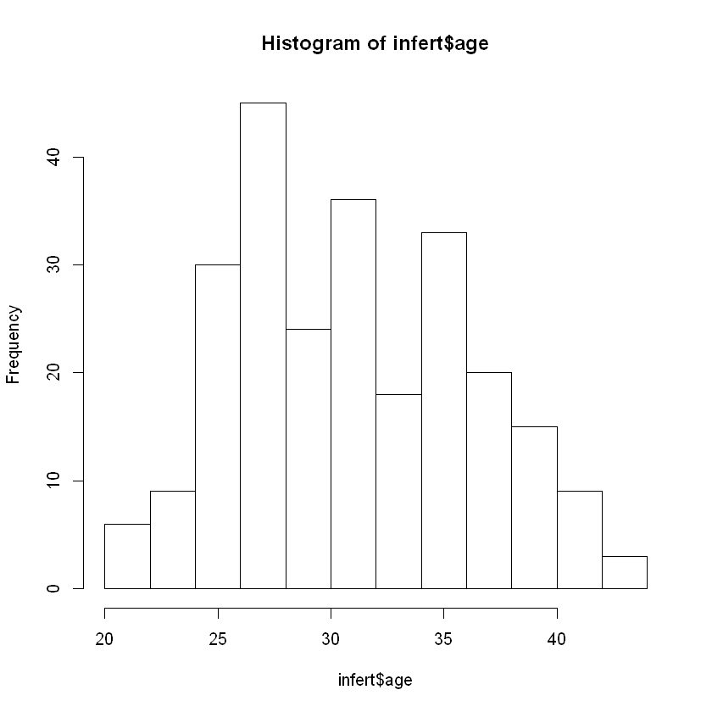

In [ ]:

​

# Looking at effects of multiple abortions:

In [ ]:

​

In [149]:

infert3**<-**infert[induced**+**spontaneous**>**2] *#show cases where they have definitely had 3 or more abortions*

In [150]:

summary(infert3)

education age parity induced case   
 0-5yrs :1 Min. :24.00 Min. :3.000 Min. :1.000 Min. :0.0000   
 6-11yrs:8 1st Qu.:26.50 1st Qu.:3.000 1st Qu.:1.000 1st Qu.:0.0000   
 12+ yrs:6 Median :28.00 Median :4.000 Median :2.000 Median :1.0000   
 Mean :29.93 Mean :4.067 Mean :1.533 Mean :0.6667   
 3rd Qu.:35.00 3rd Qu.:5.000 3rd Qu.:2.000 3rd Qu.:1.0000   
 Max. :37.00 Max. :6.000 Max. :2.000 Max. :1.0000   
 spontaneous stratum pooled.stratum   
 Min. :1.000 Min. : 1.00 Min. : 3.00   
 1st Qu.:1.000 1st Qu.:17.00 1st Qu.:34.00   
 Median :1.000 Median :29.00 Median :38.00   
 Mean :1.467 Mean :32.67 Mean :42.27   
 3rd Qu.:2.000 3rd Qu.:51.00 3rd Qu.:57.00   
 Max. :2.000 Max. :68.00 Max. :62.00

In [155]:

infert1**<-**infert[induced**+**spontaneous**<**2]

summary(infert1)

education age parity induced case   
 0-5yrs : 4 Min. :21.00 Min. :1.000 Min. :0.000 Min. :0.0000   
 6-11yrs:80 1st Qu.:28.00 1st Qu.:1.000 1st Qu.:0.000 1st Qu.:0.0000   
 12+ yrs:75 Median :31.00 Median :1.000 Median :0.000 Median :0.0000   
 Mean :31.62 Mean :1.472 Mean :0.283 Mean :0.2579   
 3rd Qu.:35.50 3rd Qu.:2.000 3rd Qu.:1.000 3rd Qu.:1.0000   
 Max. :44.00 Max. :4.000 Max. :1.000 Max. :1.0000   
 spontaneous stratum pooled.stratum   
 Min. :0.0000 Min. : 2.00 Min. : 1.00   
 1st Qu.:0.0000 1st Qu.:22.50 1st Qu.:15.50   
 Median :0.0000 Median :43.00 Median :31.00   
 Mean :0.2956 Mean :43.71 Mean :30.53   
 3rd Qu.:1.0000 3rd Qu.:65.00 3rd Qu.:45.00   
 Max. :1.0000 Max. :83.00 Max. :60.00

In [156]:

t.test((infert1**$**parity),

**+** (infert3**$**parity))

        Welch Two Sample t-test

data: (infert1$parity) and +(infert3$parity)  
t = -10.216, df = 15.361, p-value = 3.009e-08  
alternative hypothesis: true difference in means is not equal to 0  
95 percent confidence interval:  
 -3.135259 -2.054678  
sample estimates:  
mean of x mean of y   
 1.471698 4.066667

**The two groups are significantly different with a very low p-value.**

**​**

**Women who have had 3 or more abortions have a statistically greater number off full parity births**

**than women who have had only 1 abortion.**

**Women with 3 or more abortions have had more full term pregnancies, possibly these women are more fertile, more sexually active, and/or use less protection.**

**​**

**All in all it suggests that multiple abortions does not lead to infertility.**

In [ ]:

​

# Looking at how a high school education effects parity numbers

In [151]:

*#A table with only women who have a highschool education or greater*

infert**=**as.data.table(infert)

DT1**<-**infert[education**==**"12+ yrs"]

head(DT1)

|  |  |  |  |  |  |  |  |
| --- | --- | --- | --- | --- | --- | --- | --- |
| **education** | **age** | **parity** | **induced** | **case** | **spontaneous** | **stratum** | **pooled.stratum** |
| 12+ yrs | 30 | 1 | 0 | 1 | 0 | 45 | 44 |
| 12+ yrs | 37 | 1 | 1 | 1 | 0 | 46 | 48 |
| 12+ yrs | 28 | 2 | 0 | 1 | 2 | 47 | 51 |
| 12+ yrs | 27 | 4 | 2 | 1 | 0 | 48 | 61 |
| 12+ yrs | 26 | 2 | 2 | 1 | 0 | 49 | 49 |
| 12+ yrs | 38 | 3 | 0 | 1 | 2 | 50 | 60 |

In [143]:

summary(DT1)

education age parity induced   
 0-5yrs : 0 Min. :21.00 Min. :1.000 Min. :0.0000   
 6-11yrs: 0 1st Qu.:26.00 1st Qu.:1.000 1st Qu.:0.0000   
 12+ yrs:116 Median :29.00 Median :2.000 Median :0.0000   
 Mean :29.72 Mean :1.862 Mean :0.6121   
 3rd Qu.:32.50 3rd Qu.:2.000 3rd Qu.:1.0000   
 Max. :38.00 Max. :6.000 Max. :2.0000   
 case spontaneous stratum pooled.stratum   
 Min. :0.0000 Min. :0.0000 Min. :45.00 Min. :39.00   
 1st Qu.:0.0000 1st Qu.:0.0000 1st Qu.:54.00 1st Qu.:44.00   
 Median :0.0000 Median :0.0000 Median :64.00 Median :49.00   
 Mean :0.3362 Mean :0.6293 Mean :63.91 Mean :49.37   
 3rd Qu.:1.0000 3rd Qu.:1.0000 3rd Qu.:73.25 3rd Qu.:54.00   
 Max. :1.0000 Max. :2.0000 Max. :83.00 Max. :63.00

In [105]:

*#Make a table with everyone with less than 12 years of education*

DT2 **<-** infert[education **%in%** c("0-5yrs","6-11yrs")]

head(DT2)

|  |  |  |  |  |  |  |  |
| --- | --- | --- | --- | --- | --- | --- | --- |
| **education** | **age** | **parity** | **induced** | **case** | **spontaneous** | **stratum** | **pooled.stratum** |
| 0-5yrs | 26 | 6 | 1 | 1 | 2 | 1 | 3 |
| 0-5yrs | 42 | 1 | 1 | 1 | 0 | 2 | 1 |
| 0-5yrs | 39 | 6 | 2 | 1 | 0 | 3 | 4 |
| 0-5yrs | 34 | 4 | 2 | 1 | 0 | 4 | 2 |
| 6-11yrs | 35 | 3 | 1 | 1 | 1 | 5 | 32 |
| 6-11yrs | 36 | 4 | 2 | 1 | 1 | 6 | 36 |

In [107]:

tail(DT2)

|  |  |  |  |  |  |  |  |
| --- | --- | --- | --- | --- | --- | --- | --- |
| **education** | **age** | **parity** | **induced** | **case** | **spontaneous** | **stratum** | **pooled.stratum** |
| 6-11yrs | 30 | 3 | 0 | 0 | 1 | 39 | 30 |
| 6-11yrs | 28 | 1 | 0 | 0 | 0 | 40 | 8 |
| 6-11yrs | 39 | 3 | 0 | 0 | 0 | 41 | 33 |
| 6-11yrs | 35 | 1 | 0 | 0 | 0 | 42 | 11 |
| 6-11yrs | 41 | 1 | 0 | 0 | 0 | 43 | 15 |
| 6-11yrs | 37 | 2 | 0 | 0 | 0 | 44 | 25 |

In [145]:

summary(DT2)

education age parity induced   
 0-5yrs : 12 Min. :21.00 Min. :1.000 Min. :0.0000   
 6-11yrs:120 1st Qu.:28.75 1st Qu.:1.000 1st Qu.:0.0000   
 12+ yrs: 0 Median :34.00 Median :2.000 Median :0.0000   
 Mean :33.07 Mean :2.295 Mean :0.5379   
 3rd Qu.:37.00 3rd Qu.:3.000 3rd Qu.:1.0000   
 Max. :44.00 Max. :6.000 Max. :2.0000   
 case spontaneous stratum pooled.stratum   
 Min. :0.0000 Min. :0.0000 Min. : 1.00 Min. : 1.00   
 1st Qu.:0.0000 1st Qu.:0.0000 1st Qu.:11.75 1st Qu.:11.75   
 Median :0.0000 Median :0.0000 Median :22.50 Median :19.50   
 Mean :0.3333 Mean :0.5303 Mean :22.50 Mean :19.70   
 3rd Qu.:1.0000 3rd Qu.:1.0000 3rd Qu.:33.25 3rd Qu.:28.25   
 Max. :1.0000 Max. :2.0000 Max. :44.00 Max. :38.00

In [142]:

hist(infert**$**parity, breaks=6)

*#Parity is the number of pregancies the women in the study carried out to term*

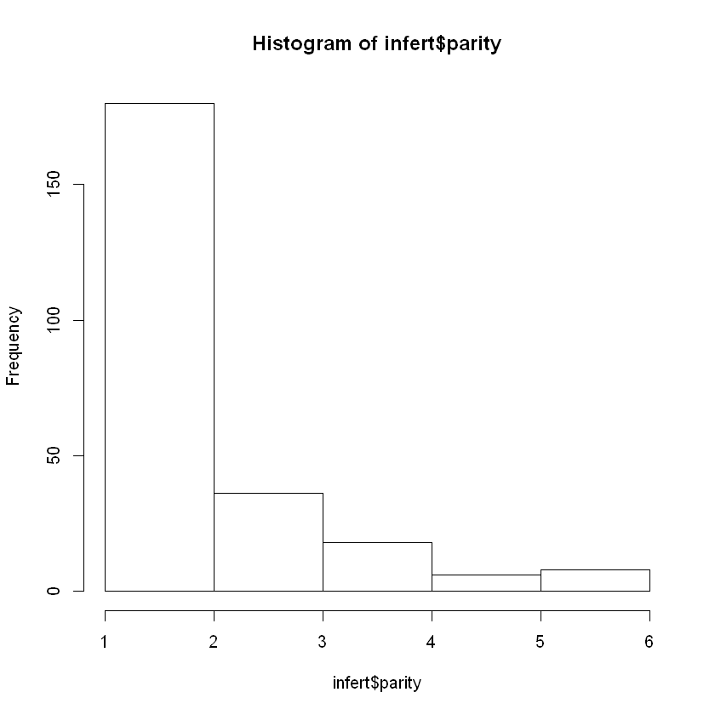

In [140]:

*#DT2 was our dataset of people with less than a high school education*

hist(DT2**$**parity, breaks=6)

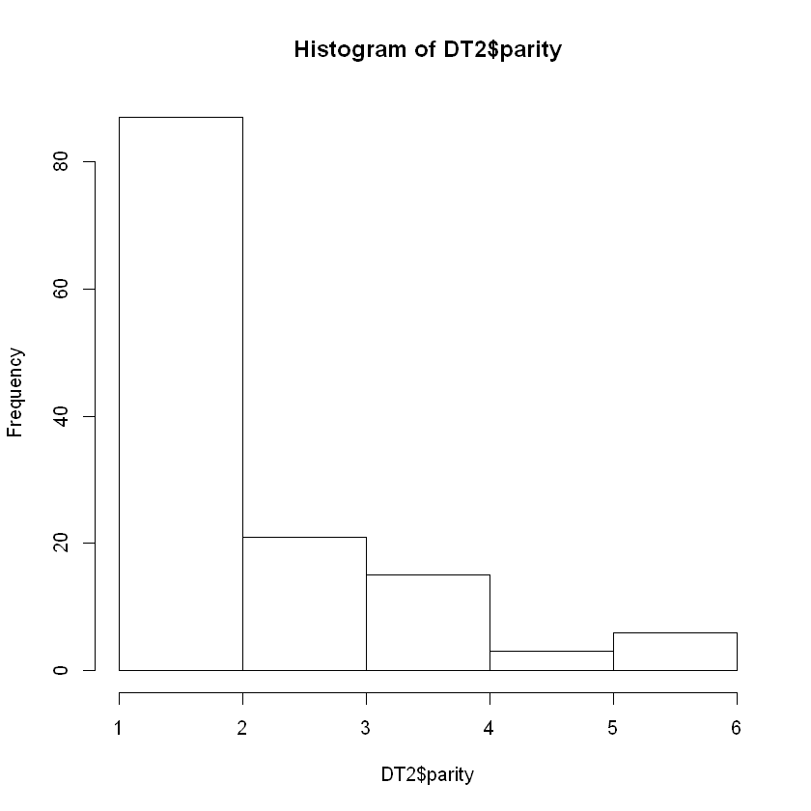

In [141]:

*#DT1 was education 12+ years, we see that there is a lower frequency of having more than 2 full "parity" births*

​

hist(DT1**$**parity, breaks=6)

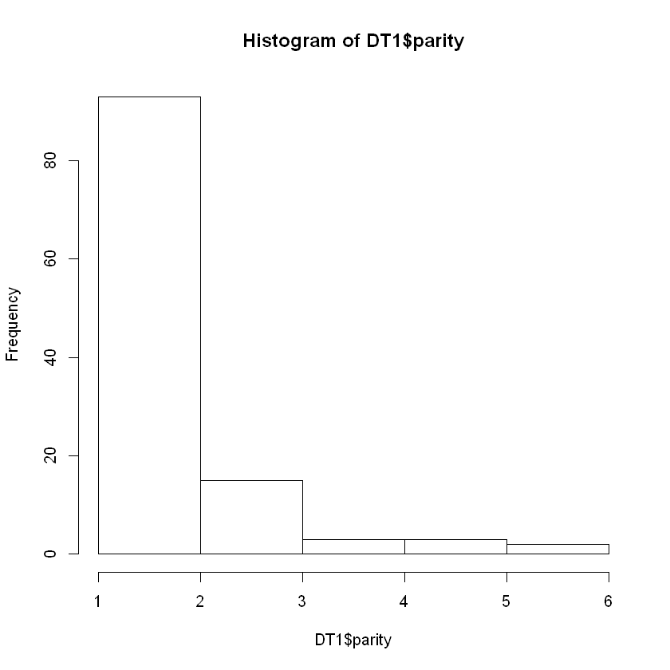

In [148]:

t.test((DT1**$**parity),

**+** (DT2**$**parity))

        Welch Two Sample t-test

data: (DT1$parity) and +(DT2$parity)  
t = -2.7938, df = 244.57, p-value = 0.005621  
alternative hypothesis: true difference in means is not equal to 0  
95 percent confidence interval:  
 -0.7389301 -0.1278410  
sample estimates:  
mean of x mean of y   
 1.862069 2.295455

In [ ]:

*#t.test proves this hypothesis that the number of parity births of highschool educated women to*

*#women with less education are significantly different with a p value lower than .05*

In [ ]:

​

­­­­